SECTION FH

CRANKCASE, CYLINDER LINERS,  
FREE-END COVER AND SUMP

CONTENTS

Chapter

Servicing Crankcase Doors .. .. .. .. .. .. .. 1

Servicing Cylinder Liners .. .. .. .. .. .. .. 2

Servicing Crankcase.. .. .. .. .. .. .. .. 3

Servicing Lubricating Oil Sump .. .. .. .. .. .. 4

Special Tools .. .. .. .. .. .. .. .. .. 5

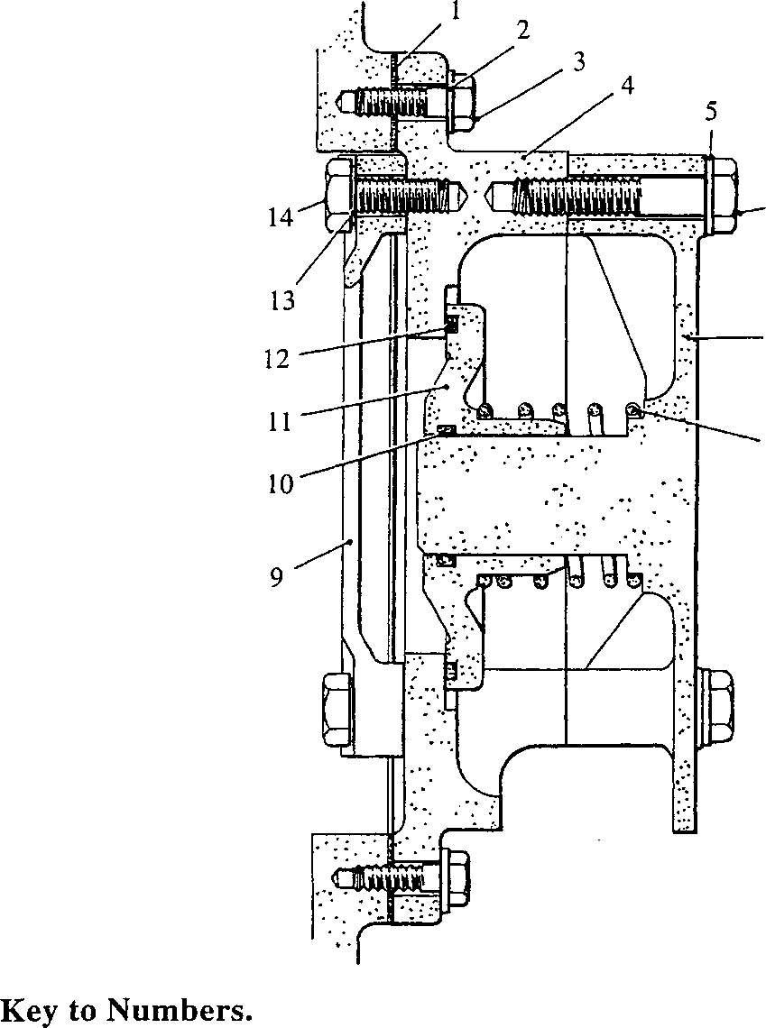SERVICING CRANKCASE DOORS

SPD00262

|  |  |  |  |
| --- | --- | --- | --- |
| 1. | Joint, door to crankcase | 8. | Spring |
| 2. | Plain washer | 9. | Splash guard |
| 3. | Setscrew | 10. | 'O' ring |
| 4. | Crankcase door | 11. | Valve |
| 5. | Plain washer | 12. | Seal |
| 6. | Bolt | 13. | Tabwasher |
| 7. | Flame shield | 14. | Setscrew |

Fig FH.l Explosion relief door

1. Four different types of crankcase door are fitted. The type of door, number off, and position on the engine, MUST be fitted at the positions stated. All doors are secured to the crankcase by setscrews and plain washers.

Removal and Dismantling.

1. Plain Door. Remove setscrews and plain washers. Remove door and discard joint.
2. Crankcase Explosion Relief Door. (Fig FH.l) Remove as for plain door. Bend back tabwashers (13), release setscrews (14), and remove splash guard (9). Remove bolts (6) and plain washers (5), and remove flame shield (7). Remove spring (8) and valve (11). Discard 'O' ring (10) and seal (12).
3. Dipstick Door. (Fig FH.2) Remove dipstick (13). Remove setscrews (9), setbolts (16) and (18), and plain washers (10). Remove the door complete with dipstick guide tube (17). Discard joint (11). DO NOT dismantle the door except to renew components. If this is necessary, unscrew extension (14), and using a suitable drift, drive guide tube (17) through ferrule (15). Remove ferrule.
4. Oil Drain Door. (Fig FH.2) Compress spring (6) by pushing carrier (7) upwards until it is clear of door boss (20). With the spring compressed, hold plunger (1) and withdraw it clear of cambox ferrule (21). Remove the whole assembly. Remove 'O' rings (2) and (22). Release setscrews (9) and plain washers (10), remove door (8) and discard joint (11).
5. To dismantle the drain assembly, press plunger (1) into spring carrier (7) until stepped diameter (23) is under circlip (3). Depress the circlip through the four slots in the spring carrier, and withdraw the plunger. Remove 'O' ring (4), washer (5) and spring (6).

|  |  |  |
| --- | --- | --- |
| Type of Door | Number | Position on Engine |
| Plain | 9 | A2, A3, A4, A6, A7, A8, B3, B5 and B8 |
| Oil drain | 2 | Al, B1 |
| Explosion relief | 4 | B2, B4, B6 and B7 |
| Dipstick | 1 | A5 (alternative position B5) |

Inspection.

1. Remove all old jointing material and inspect faces for indentations and burrs which may impair sealing. Examine all threaded components for serviceability. Examine springs for distortion and collapse.

Key to Numbers.

|  |  |  |  |
| --- | --- | --- | --- |
| 1. | Plunger | 13. | Dipstick |
| 2. | 'O' ring | 14. | Extension |
| 3. | Circlip | 15. | Ferrule |
| 4. | 'O' ring | 16. | Setbolt |
| 5. | Washer | 17. | Dipstick guide tube |
| 6. | Spring | 18. | Setbolt |
| 7. | Spring carrier | 19. | Crankcase door, dipstick type |
| 8. | Crankcase door - drain type | 20. | Door boss |
| 9. | Setscrew | 21. | Cambox ferrule |
| 10. | Plain washer | 22. | 'O’ ring |
| 11. | Joint | 23. | Stepped diameter |
| 12. | Plug |  |  |

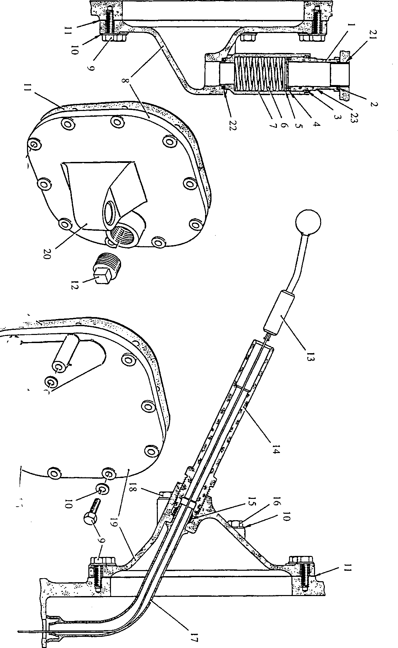

Fig FH.2 Oil drain and dipstick

Assembly and Fitting.

NOTE All joints and 'O’ rings must be fitted dry.

1. Plain Door. Using a new joint, secure the door in position with setscrews and plain washers.
2. Explosion Relief Door. (Fig FH.l) Fit a new 'O' ring (10) to the bore of valve
3. . Coat the groove in the face of the valve with 'Walker's Tico' and fit a new seal
4. . Place valve (11) in position on the machined face of door (4) and fit spring (8) over the valve extension. Fit flame shield (7) ensuring that the guide extension engages with the bore of the valve and that the spring locates on the flame shield seating. Secure the flame shield with bolts (6) and plain washers (5). Place splash guard (9) in position and secure with setscrews (14) and tabwashers (13). Using a new joint (1), fit the door to the crankcase and secure with setscrews (3) and plain washers (2).
5. Dipstick Door. (Fig FH.2) Insert guide tube (17) from the rear of the door, fit ferrule (15) and extension (14). Ensuring that the guide tube will line-up with the corresponding hole in the sump etc, in the fitted position, tighten the extension (14). Fit a new joint (11) to door (19). Fit the door to the crankcase and secure with setscrews (9), setbolts (16) and (18), and plain washers (10).
6. Oil Drain Door. (Fig FH.2) Place spring (6), washer (5) and 'O' ring (4) in spring carrier (7). Fit circlip (3) to plunger (1), placing it at stepped diameter (23). Press the plunger into the spring carrier until circlip (3) can be sprung into its groove. Using a new joint (11), fit the door to the crankcase and secure with setscrews (9) and plain washers (10). Fit new 'O' rings (2) and (22), compress the assembly and fit in position, making certain that plunger (1) engages correctly over cambox ferrule (21) and that carrier (7) locates in door boss (20).

SERVICING CYLINDER LINERS

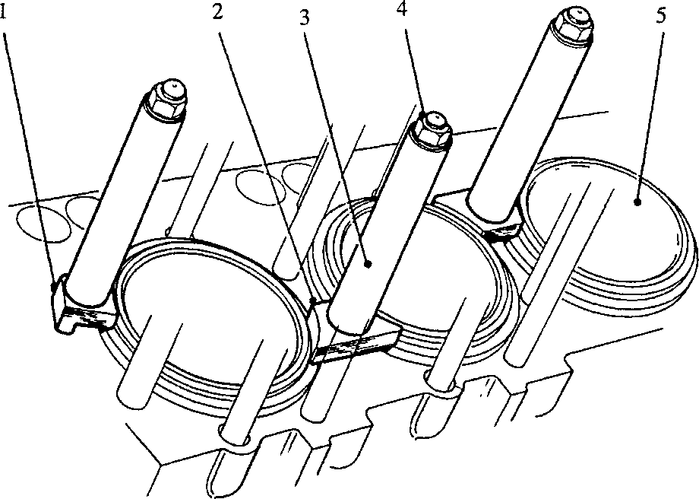SPD00209

Key to Numbers.

1. End clamp 4. Cylinder head nuts
2. Centre clamp 5. Cylinder liner
3. Distance piece

Fig FH.3 Clamping cylinder liners

.1 Owing to the possibility of asymmetric liner wear occurring in service, the STEP formed at the top limit of piston travel should be taken as the criterion for wear measurement. This step can be measured by means of wear gauge (2)(Fig FH.4) in conjunction with Dial Test Indicator (4). The method of use is as follows:-

1. Remove the cylinder heads (Section FA).
2. Secure cylinder liner (5)(Fig FH.3) to the crankcase with end clamps (1), centre clamps (2), and distance pieces (3). Secure the distance pieces with cylinder head nuts (4).
3. Remove all carbon deposits from the liner taking care to avoid scoring the chromium plated bore.
4. Visually inspect the liner to determine the maximum wear step. Place wear gauge (2) (Fig FH.4) in the bore at this point, longest end downwards, and with indicator stem (3) resting on the unworn portion of the liner (7).
5. Set the dial test indicator to 'ZERO’ and move the wear gauge downwards so that indicator stem (3) passes over wear step (5). Note the reading. Repeat at frequent intervals around the circumference of the bore.

NOTE The Dial Test Indicator may be moved relative to the wear gauge by means of grubscrew (I).

1. If the step is greater than the figure quoted in the Schedule of Clearances and Wear Limits (Section CD), replace the liner.

Removing Cylinder Liner.

1. Note and record the position of the ’F’ marking (1 )(Fig FH.7) on the liner flange, to ensure correct radial replacement when refitting the liner. Remove the liner clamps.
2. Pass shaft (9)(Fig FH.5) of the extractor gear through thrust bracket (5), and screw on withdrawing hub (3) as far as possible.
3. Tilt pivoted plate (4) to the position indicated by the dotted lines and lower the extractor gear into the liner bore until the legs of thrust bracket (5) seat on the top face of the crankcase. Ensure that the legs bear on the crankcase and not on the liner flange. Allow guide knobs (2) to rest on the liner wall, centralising the withdrawing shaft.
4. Holding shaft (9) against rotation, unscrew the withdrawing hub to lower the pivoted plate down the liner. When the toe of the plate clears the lower edge of the liner it will drop into the correct position for liner withdrawal. Care must be taken during this operation to prevent the guide knobs clearing the liner bore, thus permitting the shaft to drop against the liner.
5. Tighten the withdrawing hub to draw the pivoted plate into firm contact with the lower edge of the liner. Check that the plate is seating correctly. Continue tightening to withdraw the liner until it contacts the underside of the thrust bracket. The liner and extractor can be lifted out of the crankcase by means of a hoist shackled through one of the tommy bar holes. Remove and discard the 'O' rings fitted to the liner skirt and the 'O' ring and stainless steel joint ring fitted to the liner.

Inspection.

1. Thoroughly clean the liner. Check the outer surface of the liner for corrosion and erosion, particularly around the lower 'O’ rings grooves. Examine the underside of the top flange and locating ring for excessive fretting.
2. Check the 'Loctite' bond between locating ring (10)(Fig FH.6) and cylinder liner (6) using test ring (5). The locating ring is bonded to the liner with 'Loctite 648’ and retaining ring (11) is shrunk into place and bonded with 'Loctite 648’. If excessive fretting of the locating ring has occurred, or if the locating or retaining rings are loose, the liners should be returned to the Manufacturers for refurbishing. The use of the test ring is as follow:-
3. Thoroughly clean the test ring and liner, carefully removing any burrs which could damage any of the 'O’ rings when the tool is fitted.
4. Fit a new liner 'O' ring (7) to the groove furthest away from the bottom of the liner, and 'O' ring (8) to the test ring, this 'O' ring forms part of the tool. Apply a little petroleum jelly to both 'O' rings.
5. Release jacking screw (3) and slide the test ring over the liner until pressure plate (1) seats firmly and true on the bottom of the liner.
6. Attach a water pipe to inlet connection (4), apply water pressure and slacken vent plug (9) to release any air. Tighten the vent plug, pressurise to 100 lbf/in2, and hold for 10 minutes. If leakage is observed between the locating ring and retaining ring, or between the retaining ring and liner, the 'Loctite' bond is suspect and a new locating ring and retaining ring must be fitted.

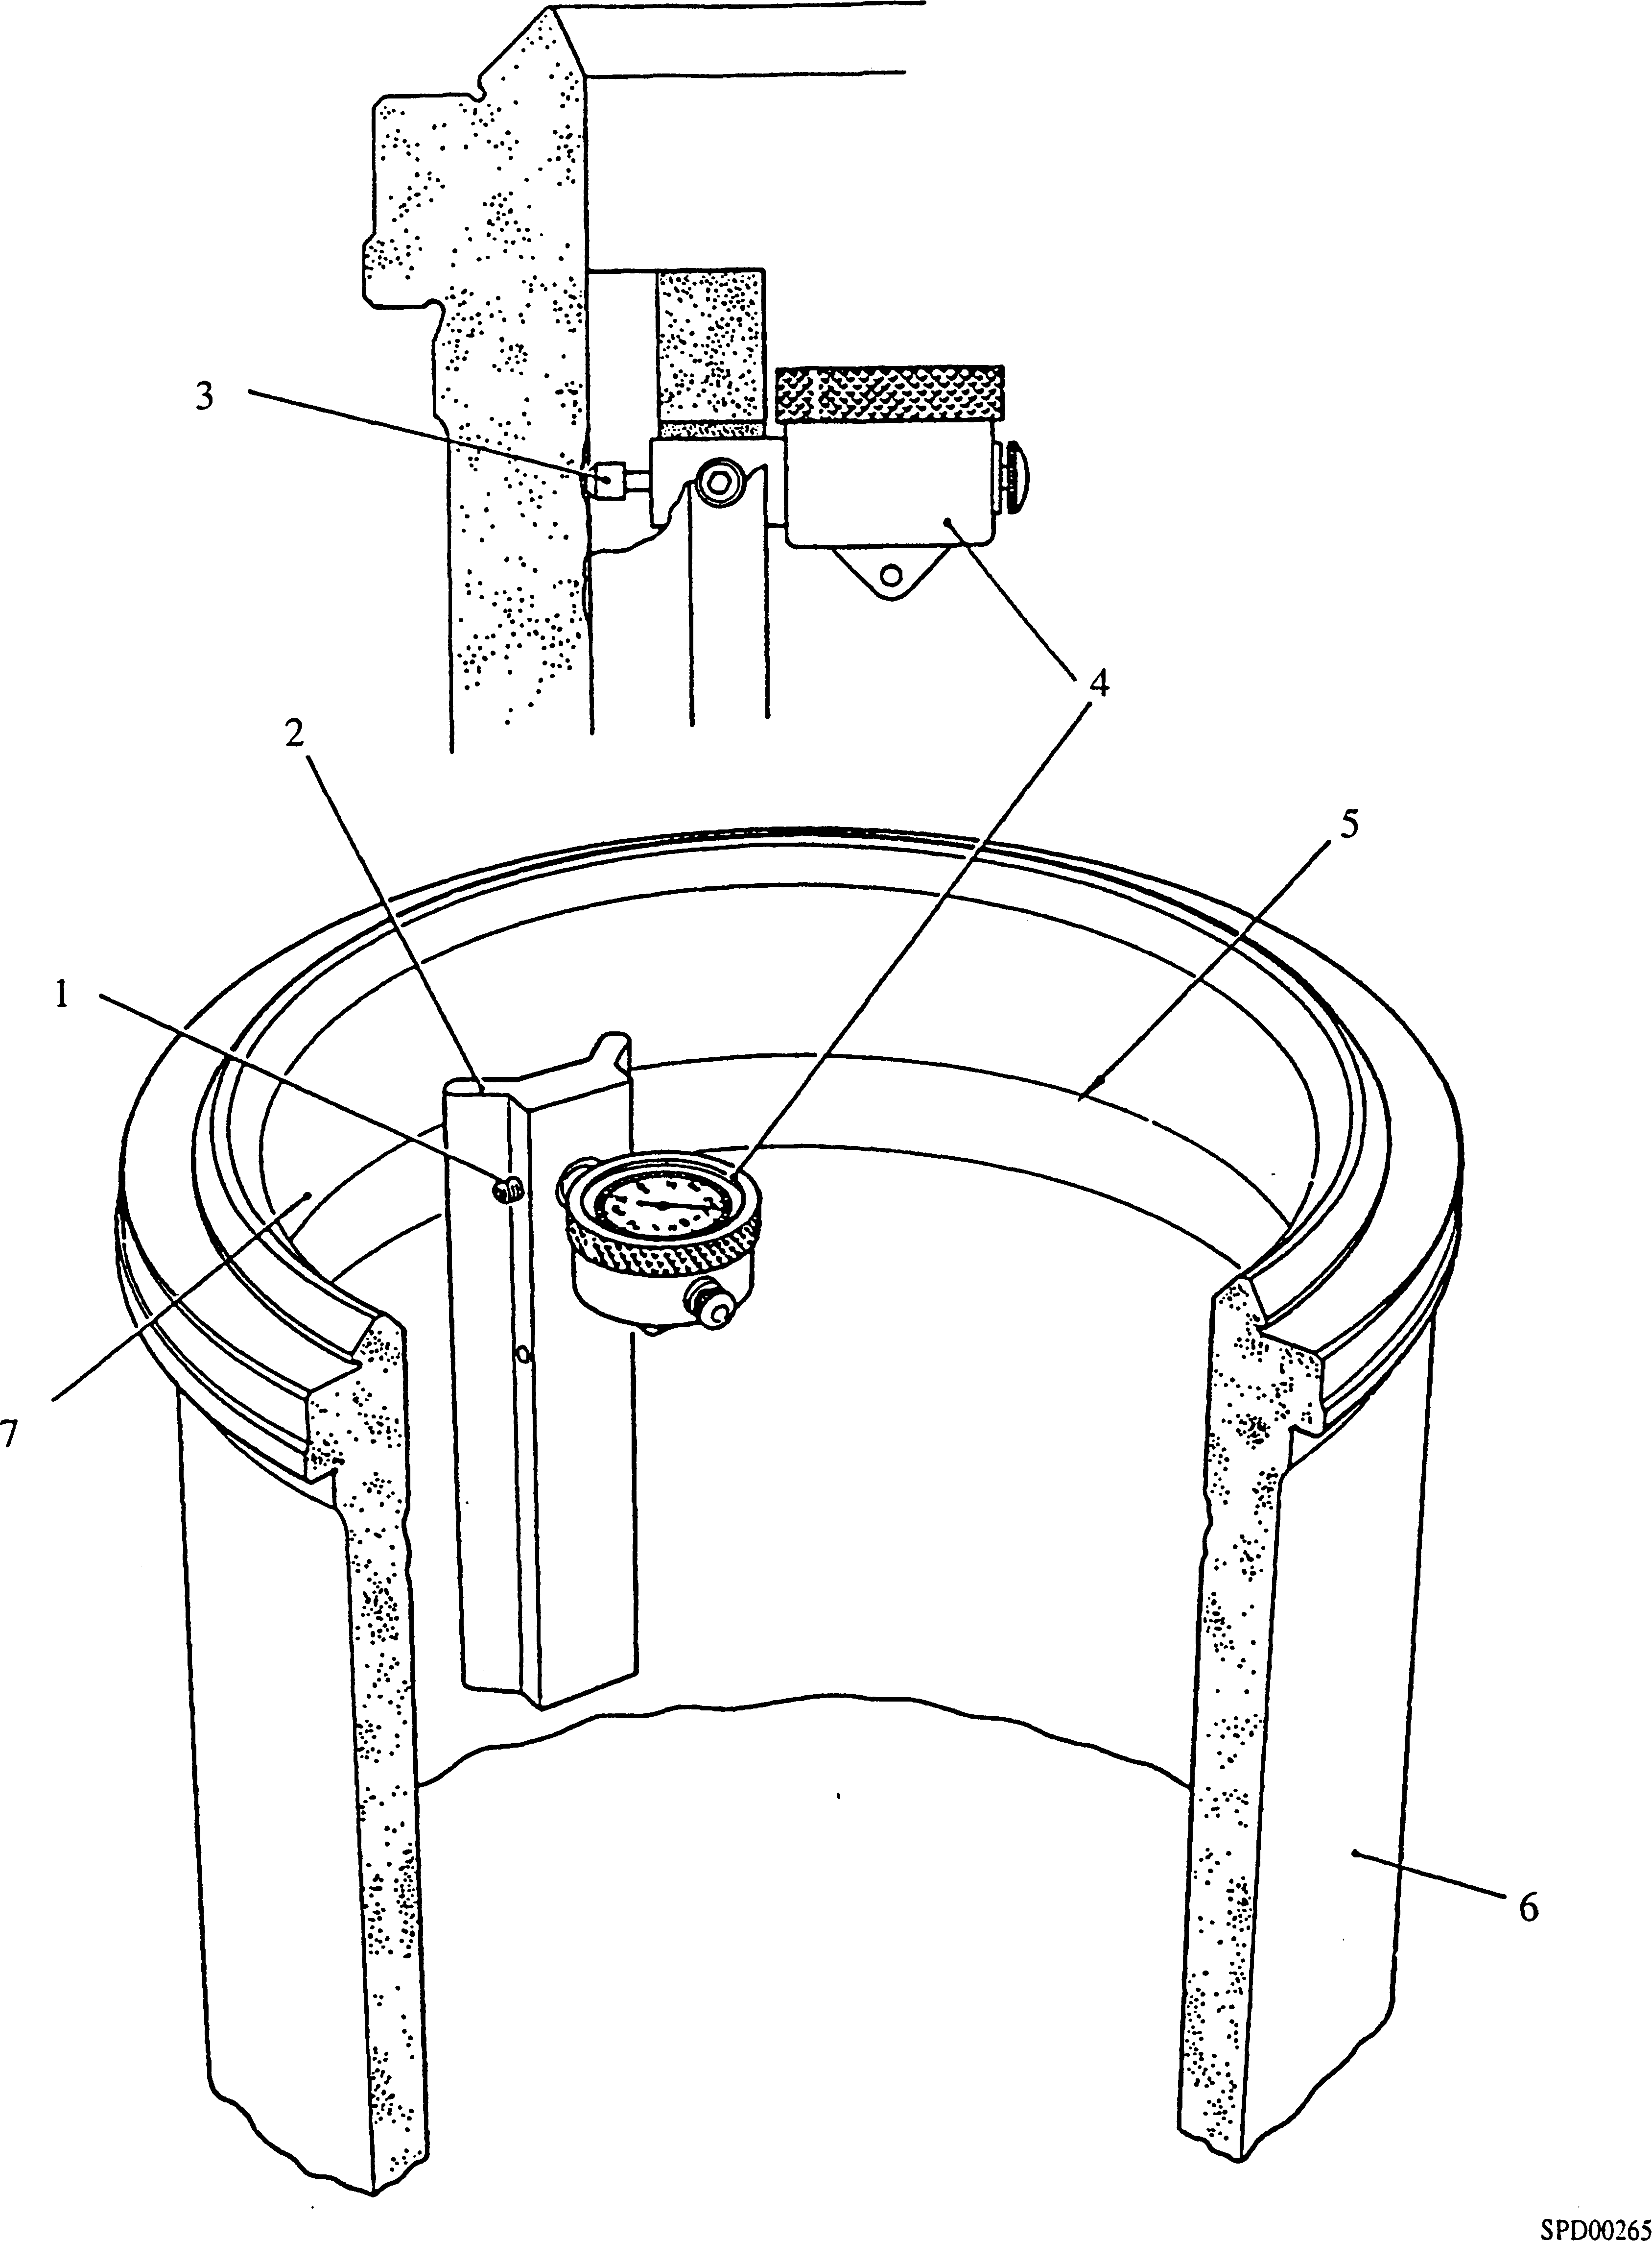

Key to Numbers.

|  |  |  |  |
| --- | --- | --- | --- |
| 1. | Grubscrew | 5. | Wear step |
| 2. | Gauge testing ring wear | 6. | Cylinder liner |
| 3. | Indicator stem | 7. | Unworn part of liner |
| 4. | Dial test indicator |  |  |

Fig FH.4 Measuring liner bore wear

If no leakage is apparent, depressurise and remove the test ring from the liner by tightening jacking screw (3). This has the effect of separating pressure plate (1) and jacking bar (2), forcing the test ring off the liner.

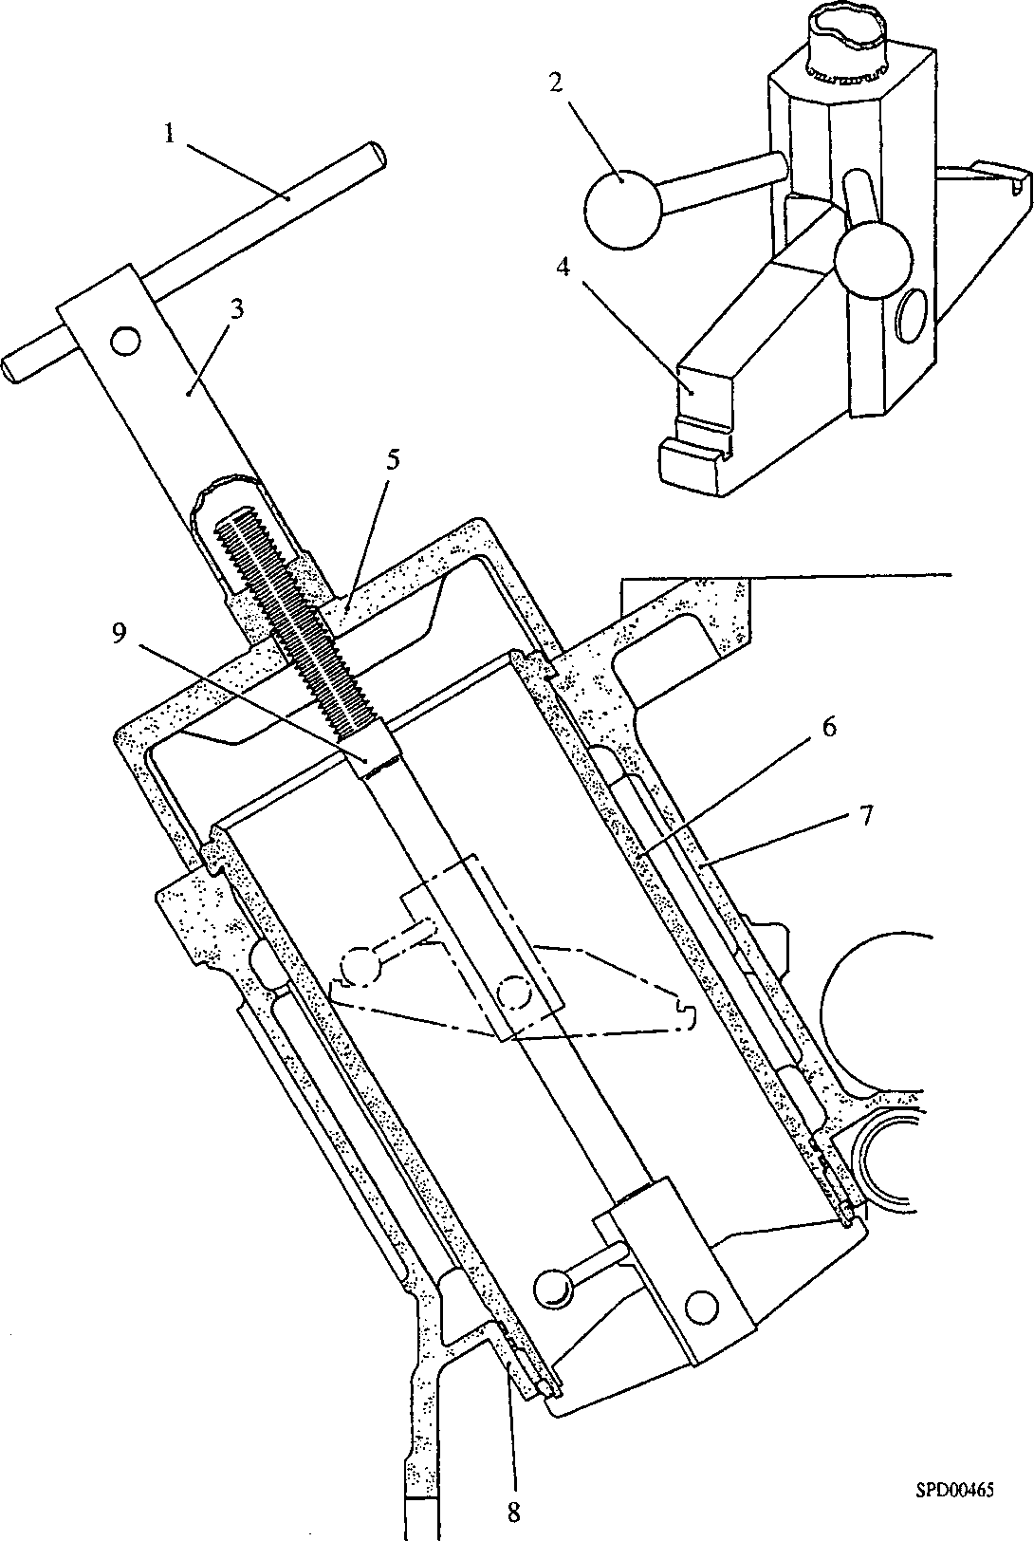

Key to Numbers.

1. Tommy bar
2. Cylinder liner
3. Crankcase
4. Diaphragm plate collar
5. Shaft
6. Guide knob
7. Withdrawing hub
8. Pivoted plate
9. Thrust bracket

Fig FH.5 Liner removal using extractor gear

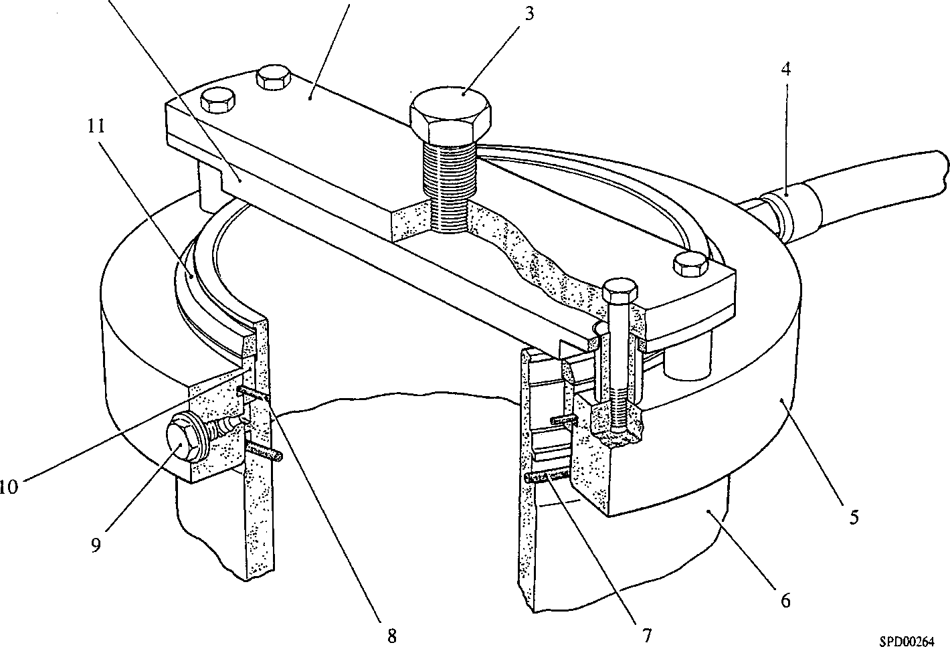

1

2

Key to Numbers.

|  |  |
| --- | --- |
| 1. | Pressure plate |
| 2. | Jacking bar |
| 3. | Jacking screw |
| 4. | Inlet connection |
| 5. | Test ring |
| 6. | Cylinder liner |

|  |  |
| --- | --- |
| 7. | 'O' ring - liner |
| 8. | 'O’ ring - test ring |
| 9. | Vent plug |
| 10. | Locating ring |
| 11. | Retaining ring |

Fig FH.6 Testing seal between locating ring and liner.

Fitting Cylinder Liner to Crankcase.

NOTE All joints and 'O' rings must be fitted dry.

1. Clean the recess in the crankcase top deck and diaphragm plate collar (8)(Fig FH.5). Clean the 'O' ring grooves in the liner skirt and the underside of the liner flange.

WARNING VITON 'O' RING SEALS WILL DECOMPOSE IF HEATED TO TEMPERATURES IN EXCESS OF 200°C (400°F) AND FORM HYDROGEN FLUORIDE GAS. THIS GAS WILL REACT WITH ANY MOISTURE (EG. ATMOSPHERIC) TO FORM HYDRO­FLUORIC ACID LIQUID. THIS ACID IS HIGHLY CORROSIVE AND CONTACT WITH THE SKIN MUST BE AVOIDED. SEE SECTION EB CHAPTER 8.

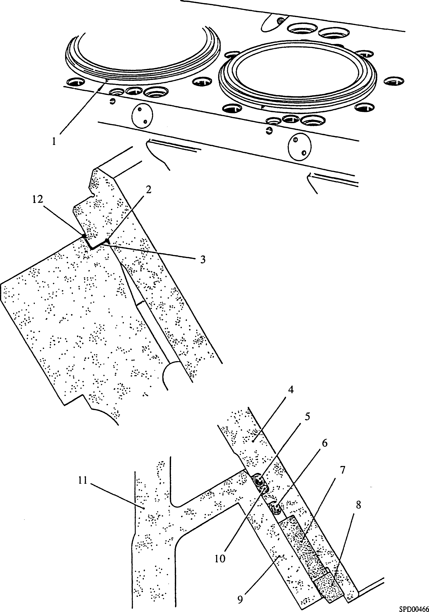

Key to Numbers.

|  |  |  |  |
| --- | --- | --- | --- |
| 1. | 'F' marking | 7. | Locating ring’ |
| 2. | 'O’ ring | 8. | Retaining ring |
| 3. | Joint ring | 9. | Diaphragm plate collar |
| 4. | Cylinder liner | 10. | 'O' ring |
| 5. | 'O' ring | 11. | Crankcase |
| 6. | Viton 'O' ring | 12. | 'O' ring |

Fig FH.7 Cylinder liner in crankcase.

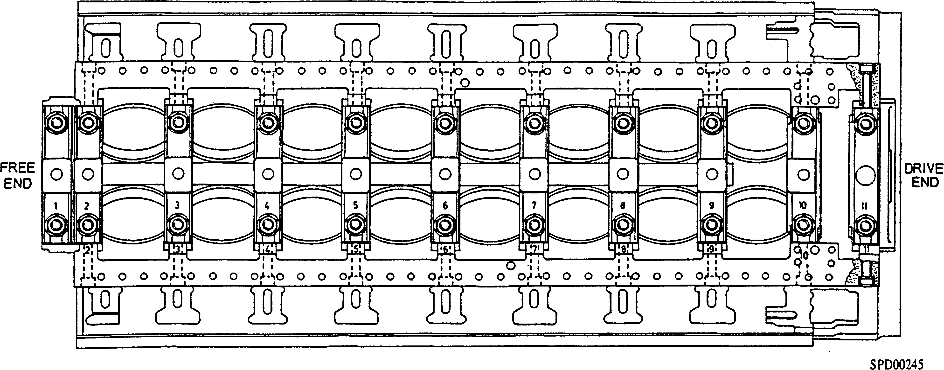

Fig FH.8 Identification of crankcase and main bearing caps.

1. Applying soft soap to all 'O' rings, fit a new 'O' ring (2)(Fig FH.7) to the undercut in the liner top flange and new 'O' rings (5) (6) and (10) to the grooves in the liner skirt. 'O' ring (10) is a spacer ring; its purpose is to hold 'O' ring (5) in the upper part of the groove. 'O' rings (2), (5), (6) and (10) are issued in sets and must be fitted with the green viton ring (6) in the position shown.
2. Place a new stainless steel joint ring (3), coated on both sides with petroleum jelly, in the recess in the crankcase top deck.

NOTE To avoid continuing thrust on an already fretted surface and to equalise bore wear, the liner may be fitted at 90° clockwise to its position when removed. The position of the letter 'F' etched on the liner top flange provides a datum for this purpose.

1. Place the liner squarely in the crankcase, press down by hand, and bed into position with a hide-faced mallet.
2. Check the liner bore over its whole length for ovality using an internal micrometer or Mercer gauge. The maximum permissible ovality is 0.0015 in (0.04 mm). Ovality at the lower portion of the liner is indicative that one or more of the sealing rings have been displaced during fitting. If ovality is found, remove the liner and check the condition of the sealing rings.
3. Fit liner clamps, blank off the coolant inlet ports and transfer passages in the crankcase top face, fill the crankcase with water and check for leakage around the top and bottom of each liner. If possible the water pressure should be raised to 60 lb/in2 (4.2 kgf/cm2) and maintained for a period of 10 minutes whilst checking for leaks.
4. After refitting the pistons and connecting rods, check the 'Bumping Clearance' (Section FA).

CHAPTER 3

SERVICING CRANKCASE

NOTE All joints and 'O' rings must be fitted dry.

1. Thoroughly clean the crankcase of old jointing material, oil and sludge. Brush through all oilways and flush out any sediment.
2. Check that all coolant spaces are free from scale deposits, corrosion and erosion.
3. Check all bearing bores and caps for fretting. Clean as necessary using a fine oilstone.
4. Examine all threaded components for serviceability.
5. When fitting the main bearings and bearing caps, note that whilst there are only ten main bearing shells, eleven caps are fitted. The free-end bearing, which is a double­width shell numbered '2', is held in position by Nos 1 and 2 bearing caps. The bearing station numbers shown in Fig FH.8, the thrust bearing station being No 10.
6. When re-assembling, use new joints and 'O' rings throughout.

Key to Numbers.

1. Crankcase
2. Cylinder head stud, outer
3. Cylinder head stud, inner
4. Setbolt
5. Tabwasher
6. Camtrough tie bar
7. Stud for camtrough cover
8. Stud for exhaust manifold
9. Camtrough cover
10. Governor mounting cover
11. Joint
12. Guide tube
13. Joint for camtrough cover

14 Lifting eyebolt

1. Mounting for crankcase breather
2. Mounting for fuel pump idler gear spindle, 'A' bank
3. Mounting for governor drive gear spindle
4. Mounting for fuel pump idler gear spindle, 'B' bank
5. Mounting for main idler gear spindle
6. Oil sealing ring
7. 'Vee'seal
8. Joint for drive-end cover
9. Dowel
10. Drive end cover
11. Centralising 'O' ring
12. Locating key
13. Main bearing cap, drive-end
14. Stud for main bearing cap
15. Baffle plate
16. Plain washer
17. Nut for main bearing cap
18. Main bearing cap, crankshaft locating
19. Mounting face for starter motor
20. Locking plate
21. Flanged dowel
22. Main bearing cap, plain
23. Tie bar
24. Mounting face for fuel pump cambox
25. Lateral capscrew for main bearing cap

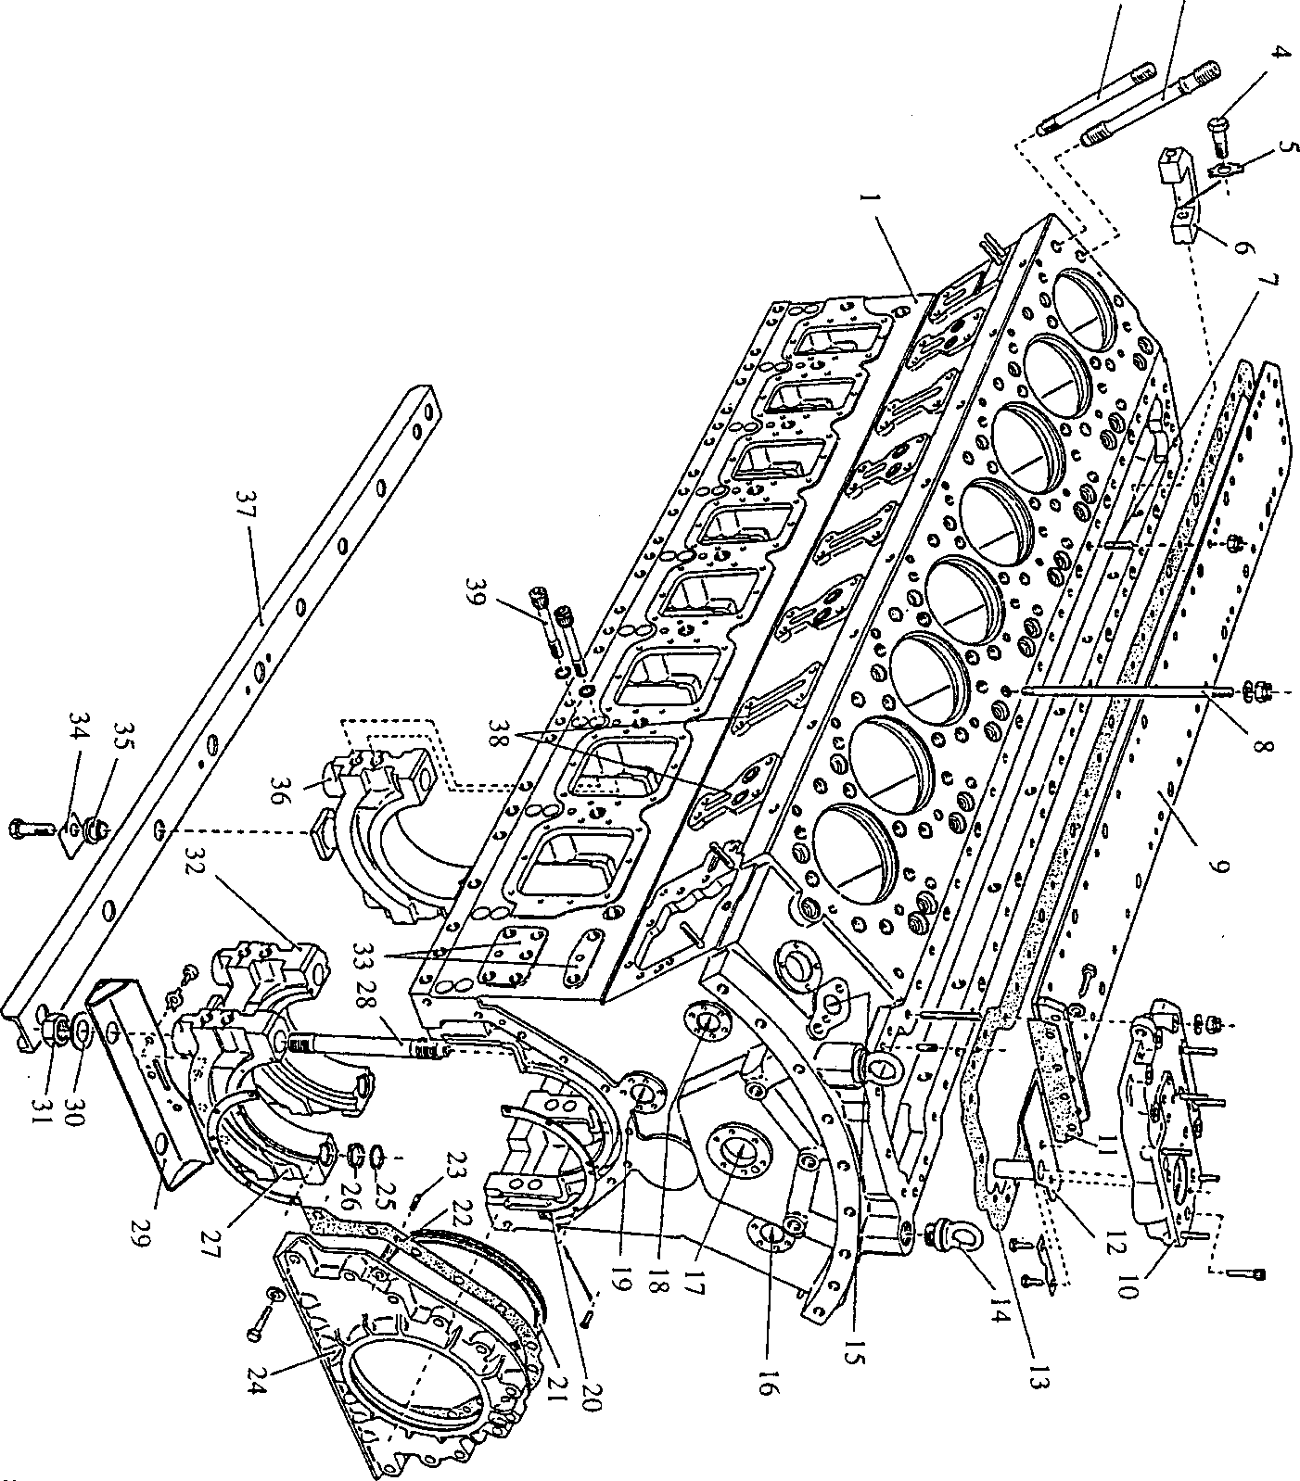

to U>

SPD00267

Fig FH.9 Crankcase

CHAPTER 4

SERVICING LUBRICATING OIL SUMP

Removal

1. Remove flywheel (Section FF).
2. Remove sea water pump and drive (Section KC)
3. Release drain pipe (25)(Fig FH.10). Remove philidas nuts (27) and remove seal carrier (26) complete with 'Vee' seal (23).
4. Release philidas nuts (30) and remove cover plate (31).
5. Remove torsional vibration dampers (Section FG).
6. Remove lubricating oil cooler (Section KF).
7. Remove the lubricating oil thermostat (Section JG).
8. Remove all oil lubricating oil pipes fitted between the engine and the free-end cover.
9. Bend back tabwashers (18), and release setbolts (19), (12), (17), (14), (20) and (15) and remove the free-end cover.
10. Fit engine lifting gear and lift the engine. Place suitable wooden battens on the floor and lower the engine until the sump rests lightly on the battens. Remove setbolts (11 )(Fig FH.ll) securing the sump to the crankcase, and setscrews (9) securing the sump to the drive-end cover, and lift the engine away.

Inspection.

NOTE Do not use cotton waste etc, for cleaning since loose fibres may become detached and enter oilways.

1. Thoroughly clean the sump, removing all traces of old jointing material/compound from the sealing faces, and all traces of sludge from the sump walls, baffles and bottom. Pay particular attention to the dipstick tube and drive-end cover drain channel. Examine the sump for cracks and check all sealing faces for burrs and indentations which could affect sealing.

Fitting.

NOTE All joints and 'O' rings must be fitted dry.

1. Fit a new joint (7) to the sump.
2. Fit engine lifting gear, lift engine and lower on to the sump, ensuring that the faces of the sump and crankcase at the free-end are correctly aligned. Fit setbolts (11) and domed washers (10), and setscrews (9) and plain washers (8). Tighten all fastenings progressively and evenly.
3. Apply soft soap to new 'O' rings (4) and (9)(Fig FH.10) and fit to the grooves in the free-end cover for the main oil gallery and the oil delivery pipe. Fit new joint (3) to the free-end cover facing.
4. Fit the free-end cover, engaging it with the lubricating oil delivery pipe and locating dowels (13), and secure with setbolts (19), new tabwashers (18) and setbolts (12), (14), (20), (15) and (17). Tighten all fastenings progressively and evenly, and bend over the tabwashers to lock.
5. Fit blanking flange (22) using a new 'O' ring (21).
6. Using new 'O' rings, fit the lubricating oil pipes between the engine free-end cover and the fuel pump camboxes.
7. Using a new joint fit the lubricating oil thermostat. (Section JG).
8. Using new 'O' rings (7) and (8) fit the oil cooler. (Section KF).
9. Fit the torsional vibration dampers (Section FG).
10. Referring to (Section FF), fit the stubshaft and facing ring.
11. Fit new joint (32) to the free-end cover. Fit cover plate (31) engaging it with dowels (16) and secure with Philidas nuts (30) and plain washers.
12. Fit a new 'Vee' seal (23). to seal carrier (26). Referring to (Section FF), fit joint (29) shim (28) and secure with philidas nuts (27) and plain washers (see Section FF). Fit oil drain pipe (25).
13. Fit flywheel.

CHAPTER 5

SPECIAL TOOLS.

The tools listed below are sufficient for general maintenance, dismantling, overhaul and assembly procedures on the crankcase, cylinder liners and sump as detailed in this section. Standard workshop tools such as ring spanners and sockets etc, are not listed.

NOTE These tools are only shown in the Illustrated Parts List if they have been ordered as part of the contract.

|  |  |  |
| --- | --- | --- |
| DESCRIPTION | PART NO | USE |
| Gauge testing ring wear | YJ70834 | )  ) To measure the wear step in the liner ) bore caused by ring wear |
| Dial test indicator | OD28374 | ) |
| Liner clamp, end | YJ70334BP3 | )  ) Used in conjunction with the cylinder |
| Liner clamp, centre | YJ70334BP4 | ) head studs and nuts to clamp the ) cylinder liners to the crankcase |
| Distance piece | Y3J70865 | ) |
| Extractor gear | Y3J70320A | To withdraw liners from crankcase |
| Engine lifting gear | 18Y3J70310E | For general engine lifting |
| Test ring | Y3J72856A | To hydraulically test the ’Loctite' bond between locating ring and cylinder liner |
| Support legs | Y3J72875 | To support crankcase during assembly procedures |

Key to Numbers.

|  |  |
| --- | --- |
| 1. | Oil inlet port, return from filter |
| 2. | Free end cover |
| 3. | Joint, free end cover to crankcase and sump |
| 4. | 'O' ring, main oil gallery |
| 5. | 'O' ring, relief valve |
| 6. | 'O' ring, relief valve |
| 7. | 'O' ring, oil cooler |
| 8. | 'O' ring, oil cooler |
| 9. | 'O' ring, oil delivery pipe from pump |
| 10. | Oil outlet port to filter |
| 11. | 'O’ ring |
| 12. | Setbolt |
| 13. | Dowel |
| 14. | Setbolt |
| 15. | Setbolt |
| 16. | Dowel |
| 17. | Setbolt |
| 18. | Tabwasher |
| 19. | Setbolt |
| 20. | Setbolt |
| 21. | 'O' ring |
| 22. | Blank flange |
| 23. | 'Vee' seal |
| 24. | Banjo screw |
| 25. | Oil drain pipe |
| 26. | Seal carrier |
| 27. | Philidas nut |
| 28. | Shim |
| 29. | Joint |
| 30. | Philidas nut |
| 31. | Cover plate |
| 32. | Joint |
| 33. | 'O' ring |

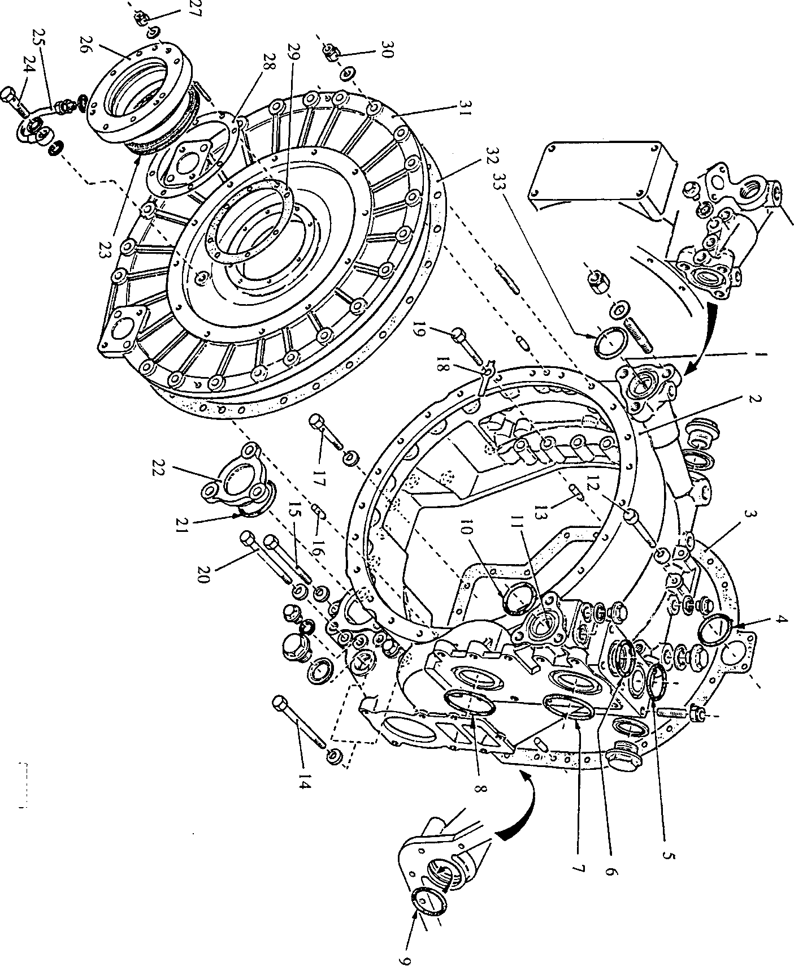

SPD00266

Fig FH.10 Free end cover

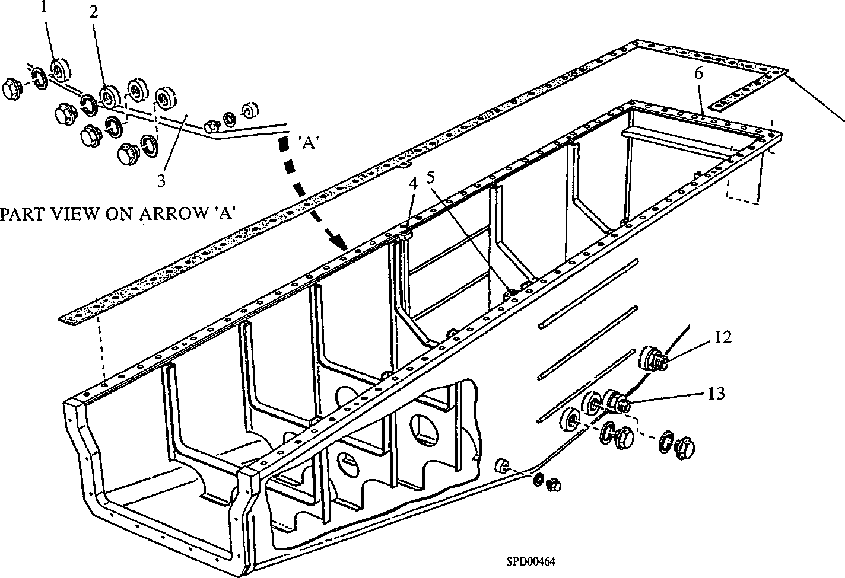Key to Numbers.

1. Alternative suction port for motorised priming pump
2. Alternative suction port for hand priming pump
3. Sump
4. Alternative position for dipstick tube
5. Dipstick tube
6. Oil drain channel from drive end cover
7. Joint, sump to crankcase
8. Plain washer
9. Setscrew, sump to drive end cover
10. Domed washer
11. Setbolt, sump to crankcase
12. Suction port for motorised priming pump
13. Suction port for hand priming pump

Fig FH.ll Lubricating oil sump